**Section-End Project - Lesson 1**

**Spring Inversion Of Control I**

### Assignment 03

There are two Model classes as below:

***Student***

studentId -> String -> S001

studentName -> String -> Steve

studentTest -> Object of type Test

***Test***

testId -> String -> T001

testTitle -> String -> “Core Java Test”

testMarks -> int -> 80

Create a spring program to create 2 student instances. First

student has taken up the test with Core Java Test with 80 as

score and the Second student has taken Oracle test with 83 as

score

In the client program display all the details of both the

students along with their test details as

well.

Instructions:

1. Follow the same type of process as in the previous two labs.
2. Create a simple maven project.
3. Edit the pom.xml using properties element or <build><plugins> element so as to have the IDE pick up the correct installed JDK version.(JDK 11). must be showing by default.
4. Add studenBean.xml to the resources folder under src/main.Boilerplate code can be copied from a previous lab’s files.

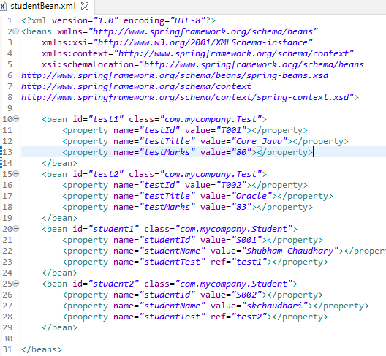

1. Create the Student and Test classes with appropriate getters and setters.
2. Create a class Main.java and call the display method on the two Student instances.
3. Run the application. Output should be as below:



